Capstone Project Weekly Progress Report
Semester | Fall-2024 Semester 3rd
Course Code | AML-3406
Section | Section 1
Project Title | Car Damage Detection
Group Name | Group B
Student names/Student IDs | Sakshi (C0908000) – TL  Bansil Patel (C0912873)  Harsh Mohile (C0912872)  Meet Patel (C0910378)  Rachit Bhatt (C0902810)
Reporting Week | Week 10
Faculty Supervisor | William Pourmajidi

Grade the level of collaboration from different aspects between team members:
(use: good, medium, below expectation)
Sakshi | Bansil Patel | Harsh Mohile | Meet Patel | Rachit Bhatt
Good | Good | Good | Good | Good

Tasks outlined in the previous Weekly Progress Report for this reporting week at the individual level and group level
  - Individual tasks (each team member)
Sakshi: Investigate how GitHub Actions can be integrated into the project for automating testing and deployment.
Bansil Patel & Meet Patel: Continue analyzing the model metrics and complete the hyperparameter tuning to optimize performance.
Harsh Mohile & Rachit Bhatt: Demonstrate a fully automated Docker deployment process for multiple environments (e.g., development, staging, production) using GitHub Actions.
2.2 Your team’s tasks
- Finalize the analysis of the model's performance metrics and proceed with hyperparameter optimization.
- Continue enhancing the Docker deployment workflow using GitHub Actions and ensure it works seamlessly across different environments.

Progress made in Reporting Week at an individual level and group level
  - Individual progress
Sakshi: Set up Docker containers and explored Docker Compose for multi-container management.
Bansil Patel & Meet Patel: Evaluated model performance (accuracy, speed) and started hyperparameter tuning on the selected model.
Harsh Mohile & Rachit Bhatt: Demonstrated automated deployment using GitHub Actions and Docker, optimizing windows.
  - Your team’s progress
- Configured GitHub Actions to automate Docker deployment and set up a CI/CD pipeline.
- Completed model evaluation and refining the selected model with hyperparameter tuning.

The areas/tasks you could not make progress and/or complete as scheduled or the difficulties encountered in this reporting week at individual level and group level.
  - Individual project blockers
Sakshi: N/A
Bansil Patel: N/A
Meet Patel: N/A
Harsh Mohile & Rachit Bhatt: Faced challenges while setting up CI/CD workflows for multiple branches in GitHub, particularly in aligning Docker deployment with branch specific configurations.
  - Your team’s project blockers
- While no major blockers were encountered this week, the team experienced some delays in configuring the CI/CD pipeline for multiple branches, particularly when adjusting the Docker deployment scripts.

Tasks to be completed in the next week at individual level and group level
  - Individual tasks
Sakshi: Investigate how GitHub Actions can be integrated into the project for automating testing and deployment.
Bansil Patel & Meet Patel: Continue analyzing the model metrics and complete the hyperparameter tuning to optimize performance.
Harsh Mohile & Rachit Bhatt: Researching Deployment UI and Backend.
  - Your team’s tasks
- Finalize the analysis of the model's performance metrics and proceed with hyperparameter optimization.
- Researching Deployment UI and Backend.

Include the tasks from your sprint planning (GitHub/ZenHub) for the present period.
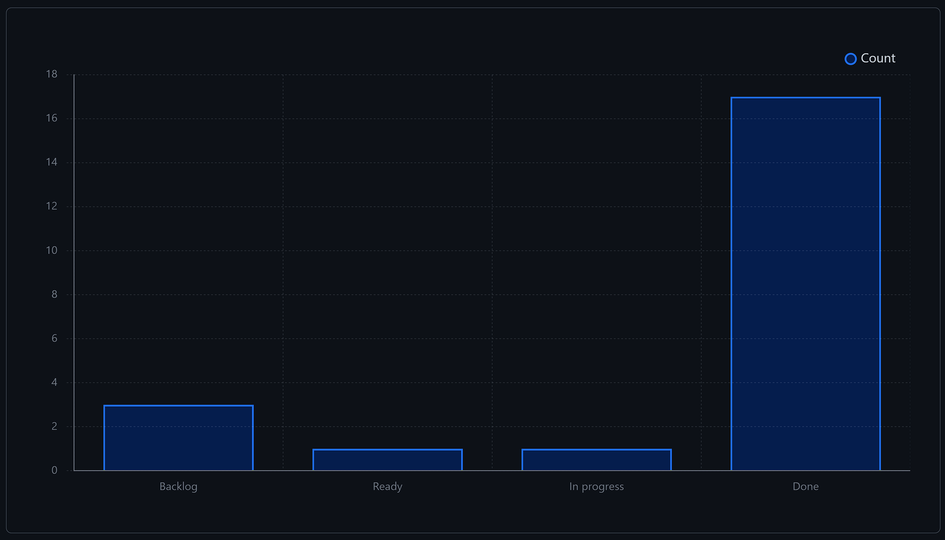
Figure 1: Weekly Activities
- In this week, there were a lot of issues resolved from the backlog, contributing to development.

Include charts/graphs (e.g., burn down charts) from your project management tool (Github/Zenhub) that shows your progress for the period of this report.
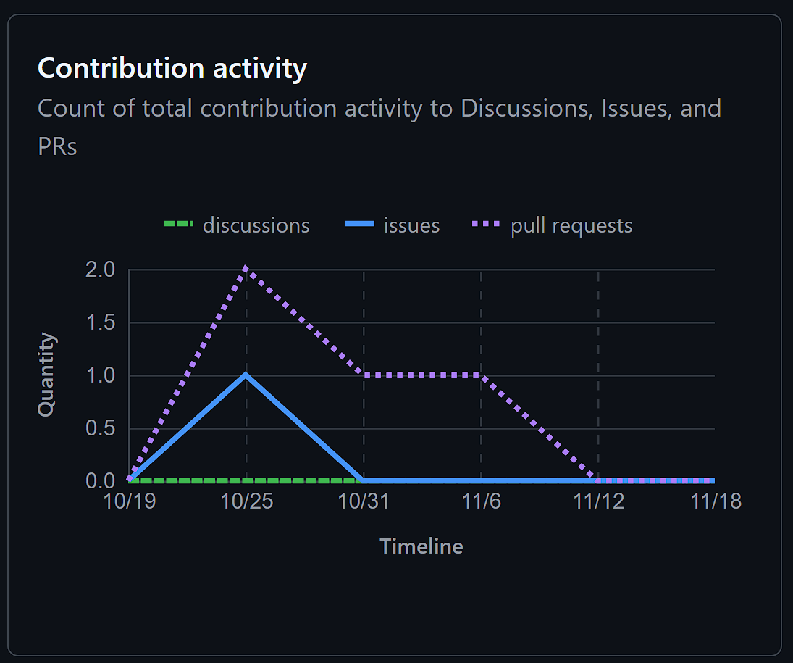
Figure 2: Contributors in the Week
- This week, we had a few PRs and issues resolved as compared to previous week, demonstrating team hard work and dedication.

Include a note and address to your project GitHub with list of codes uploaded/updated on GitHub in this reporting week.
GitHub: https://www.github.com/rachit-bhatt/Capstone-Project

